**Identity Mismatch/Sameness Mismatch:-** In relational Database, the same ness of two records is defined by primary keys. If the same value for the two primary key then they are considered identical records. Otherwise they are not same records.

In Object -oriented programming Languages, the same ness of two objects is determined by object reference , object state and both.

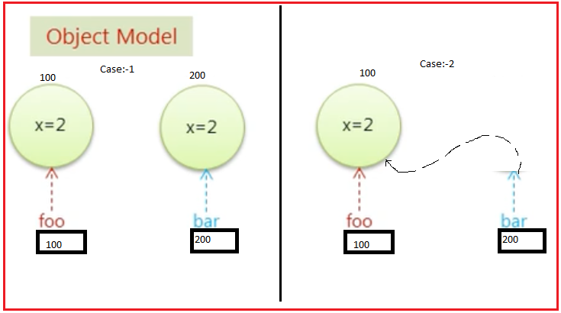

Determining the sameness of two objects in object oriented Data Model and Determining the sameness of two Records in Relational Data Model is different.

The ORM gave solution to sameness mismatch problem.